BNRC News
May 2022

Bedford Nursing & Rehab Center 480 Donald Street Bedford, NH 03110
Celebrating May  Gardening for Wildlife Month  Personal History Month  Global Health and Fitness Month  World Laughter Day  May 1  African World Heritage Day  May 5  148th Kentucky Derby  May 7  Mother’s Day (U.S.)  May 8  World Belly Dance Day  May 14  International Learn to  Swim Day  May 21  Buy a Musical  Instrument Day  May 22  Memorial Day (U.S.)  May 30 | Fun Happenings at BNRC during the month of April!  Booze & Tattoo’s, Karaoke & Cocktails, Eddy the Pony, Egg Hunt / Egg Decorating, Super Hero Day, Live Bunny Visit, A Food Tasting Party & Zumba!  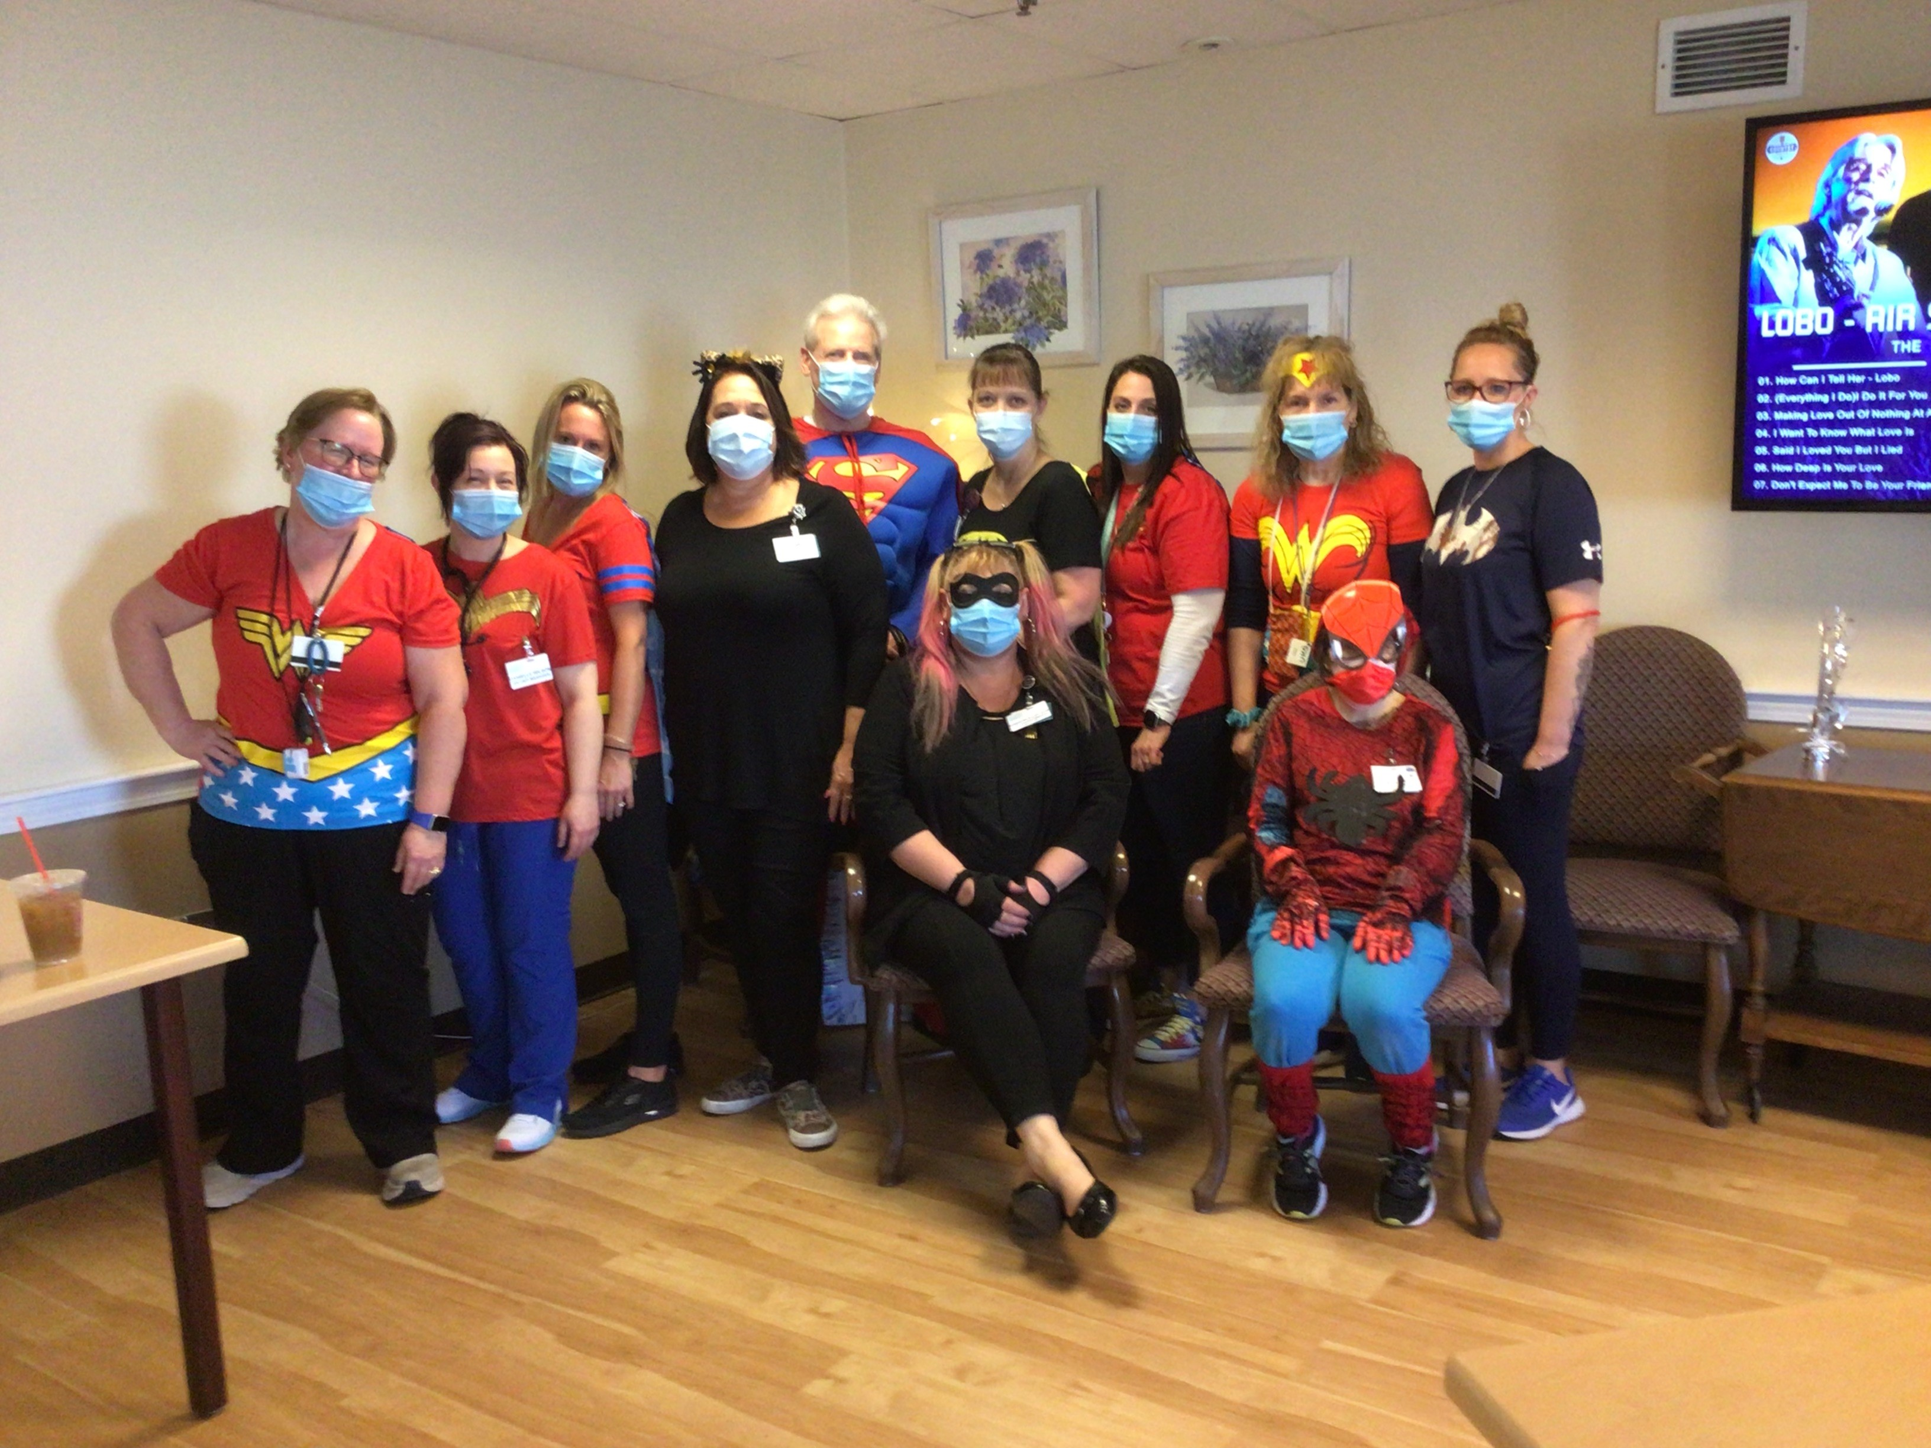
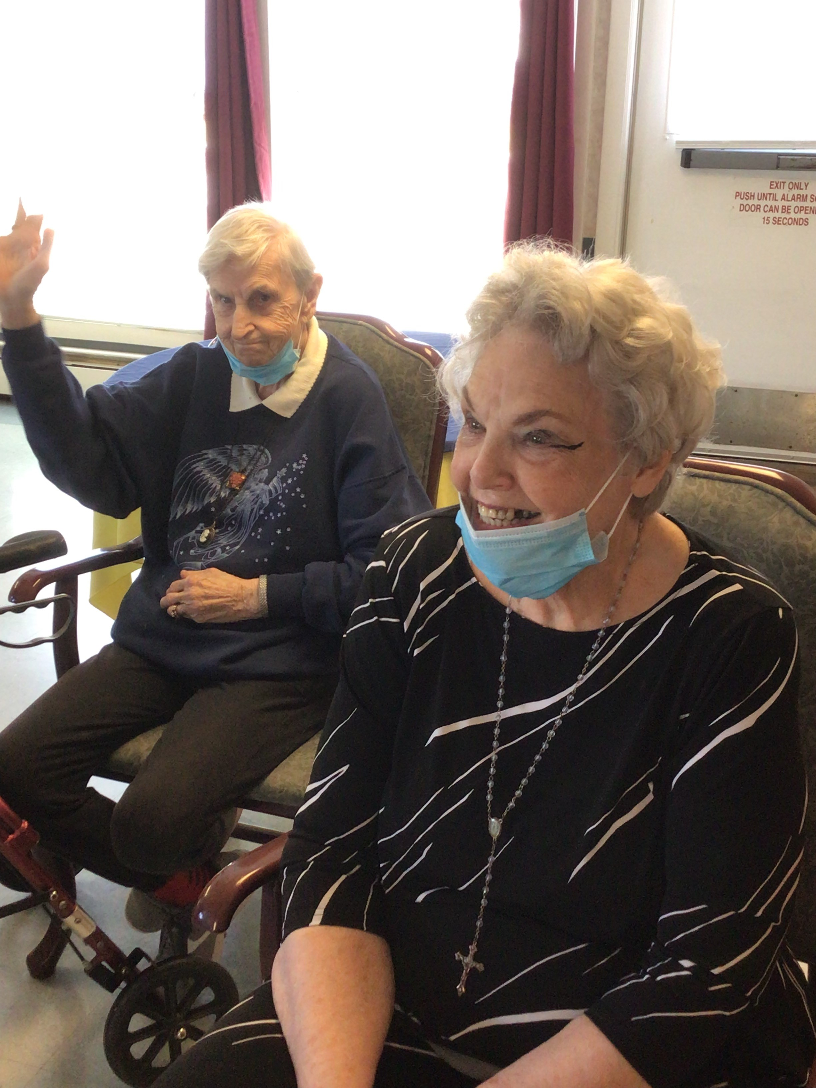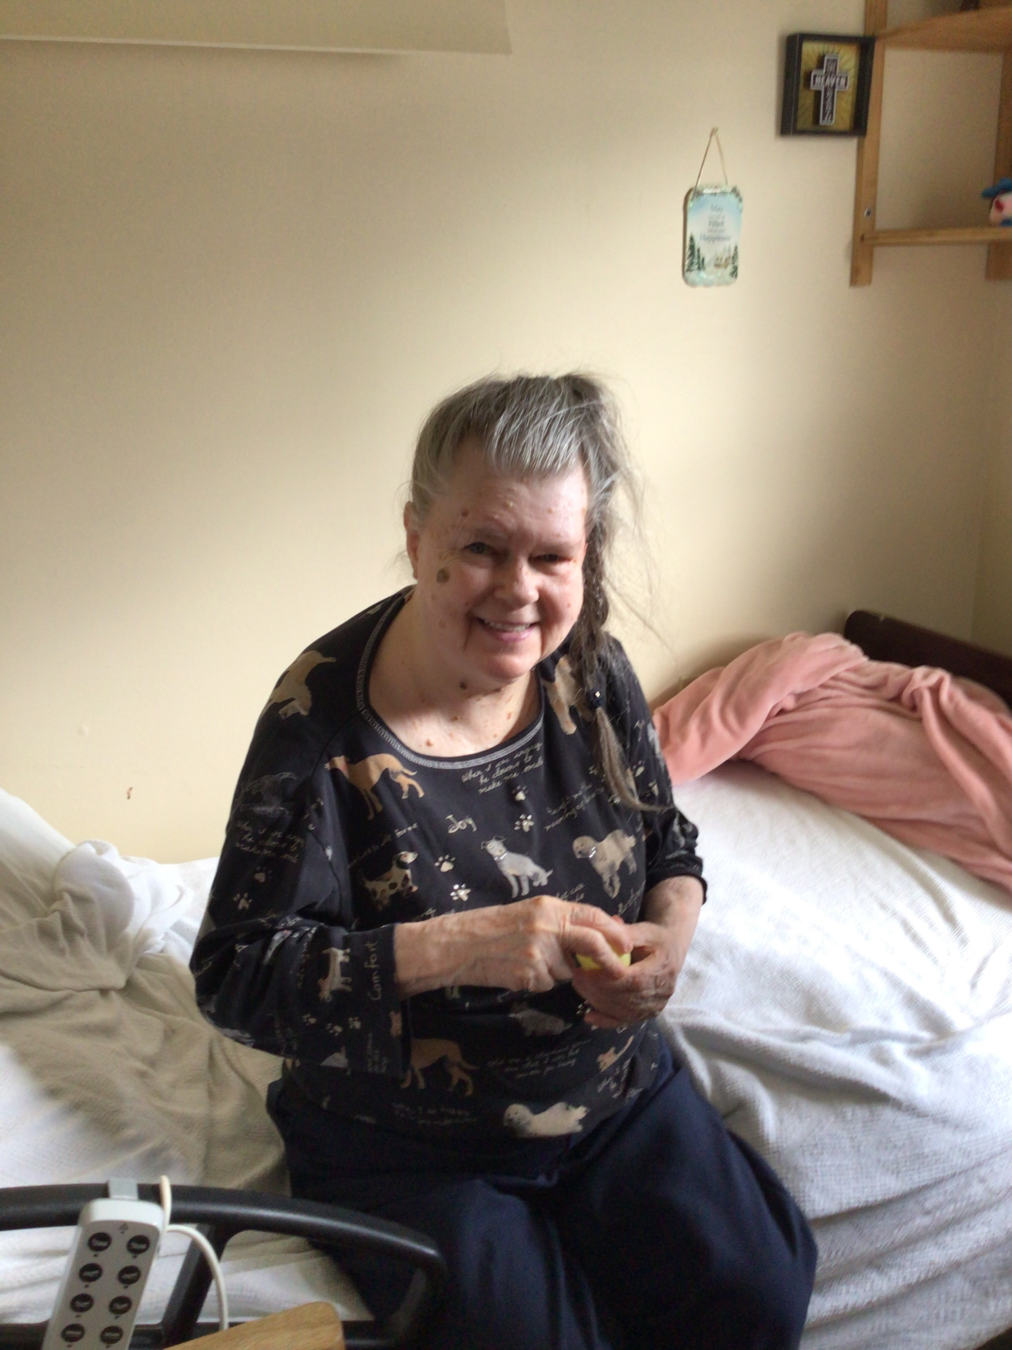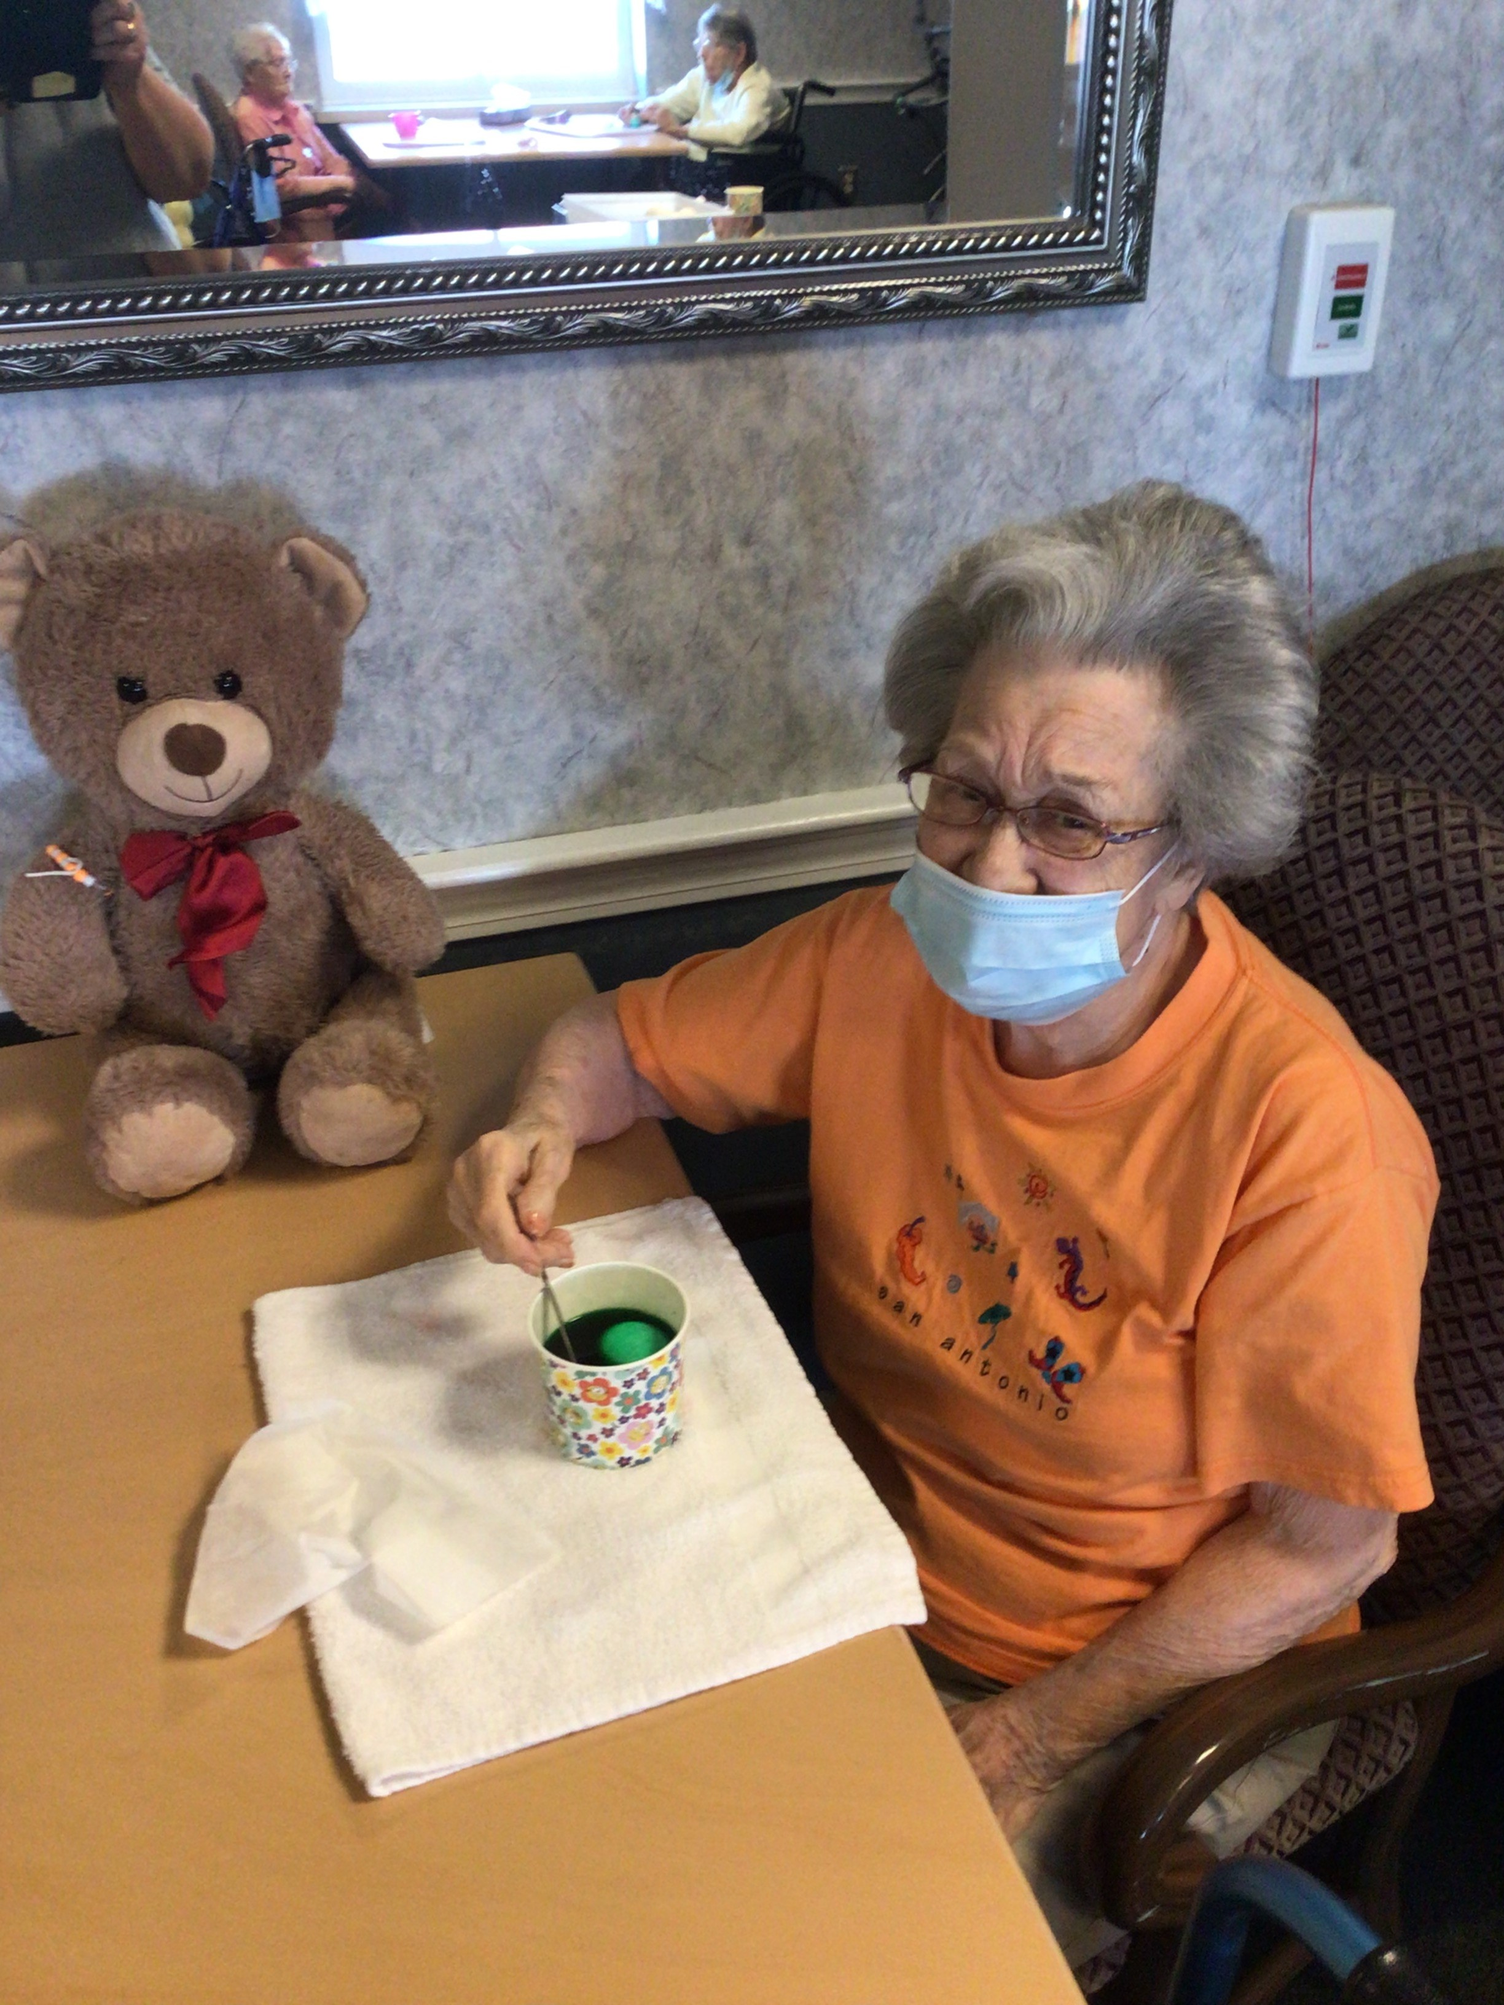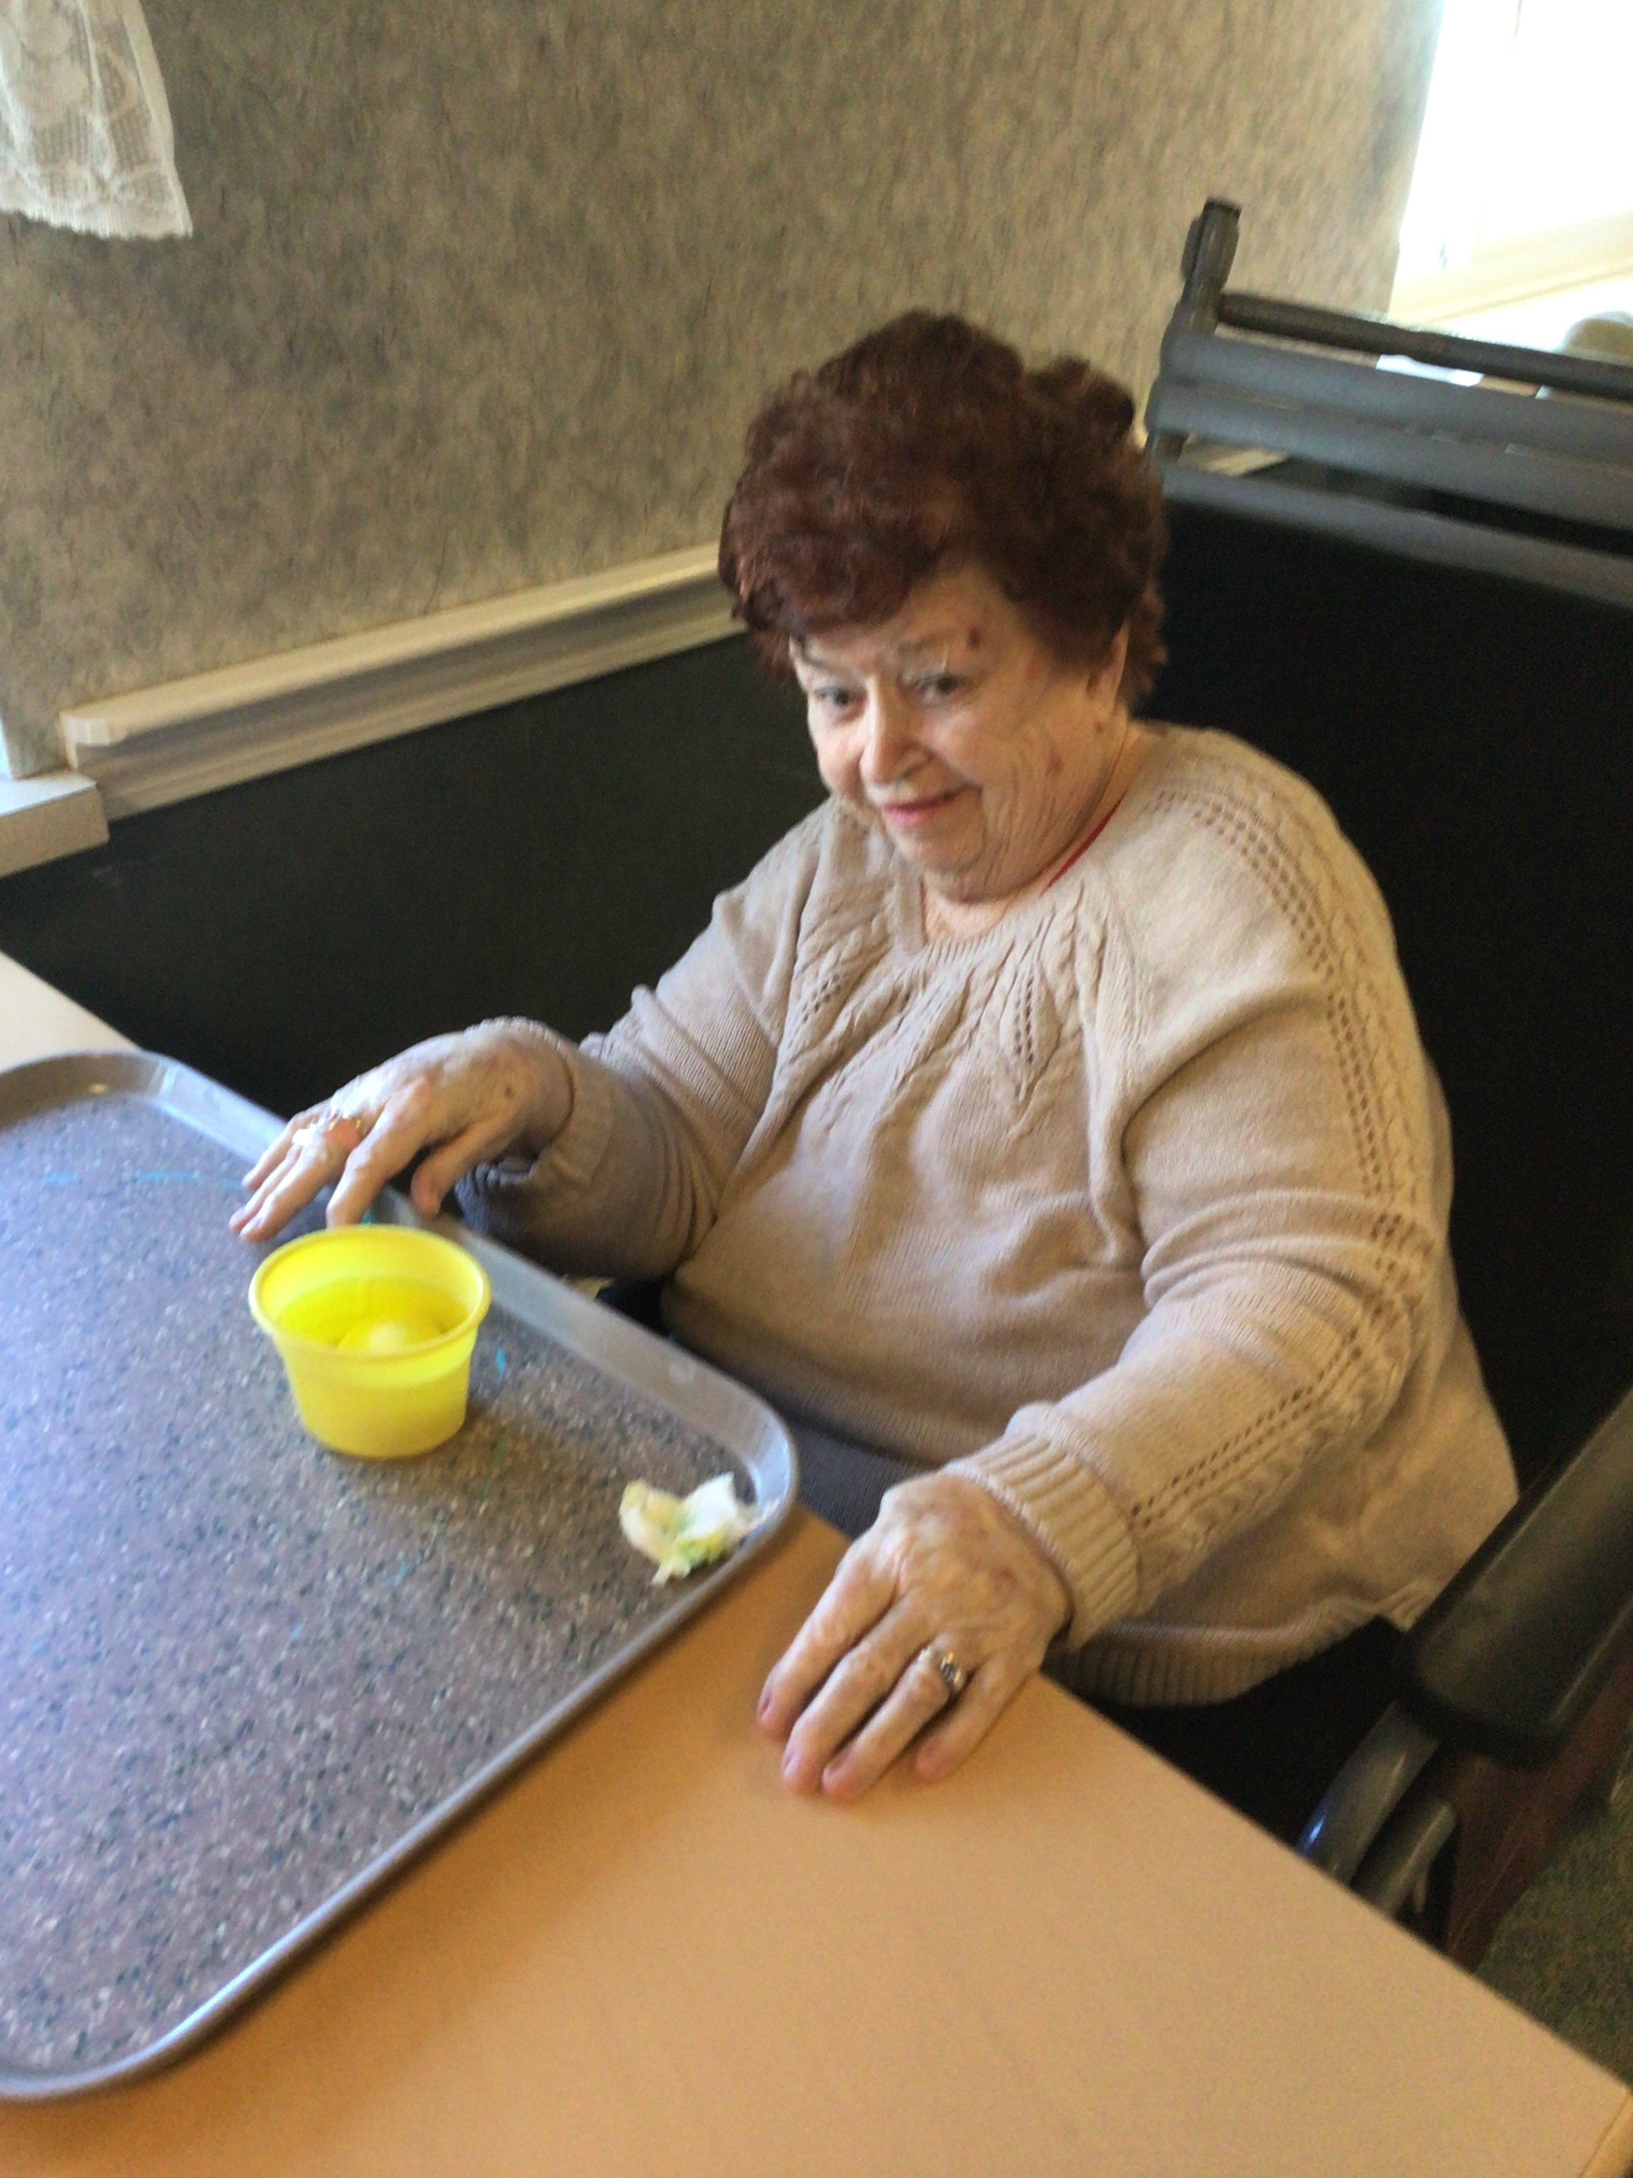  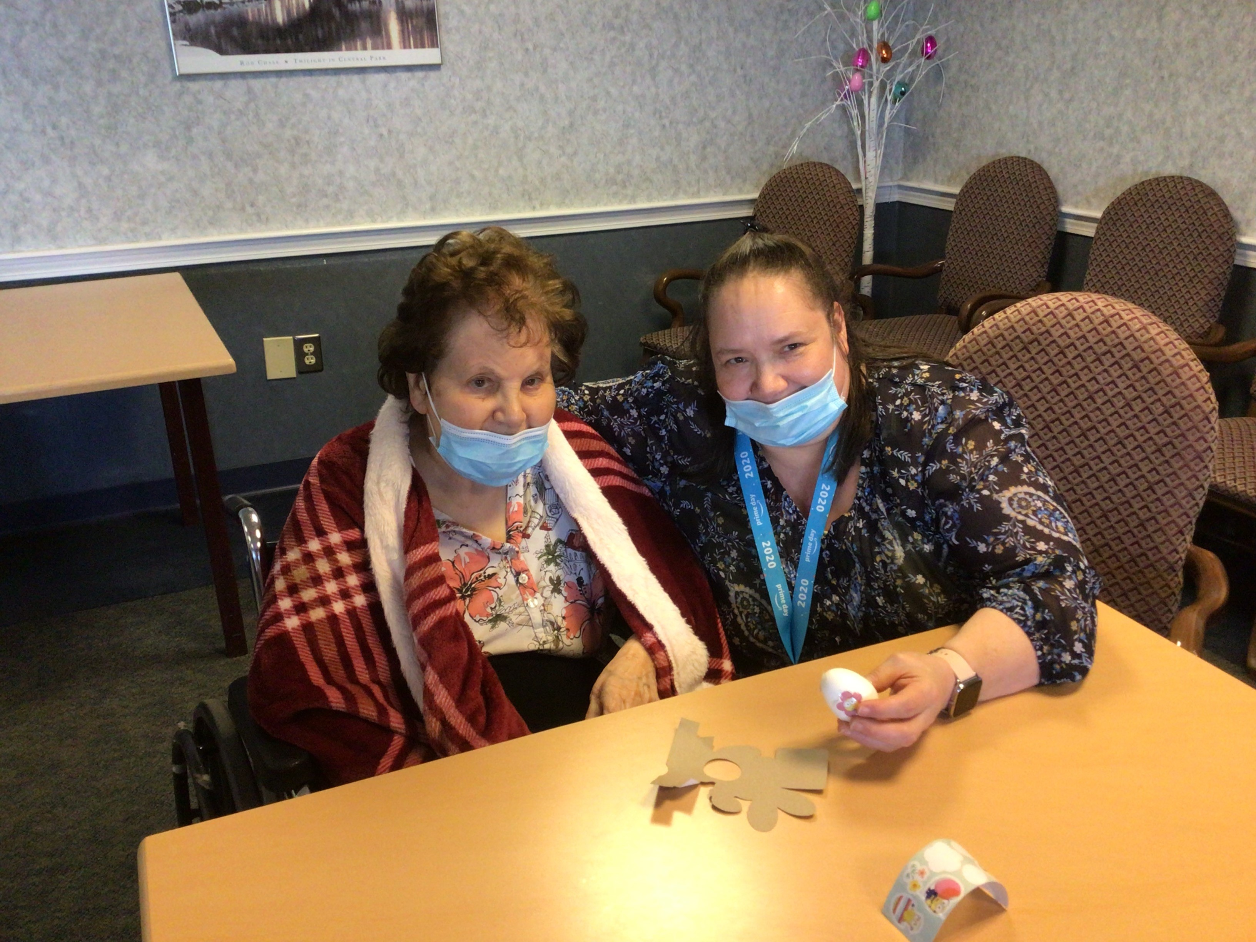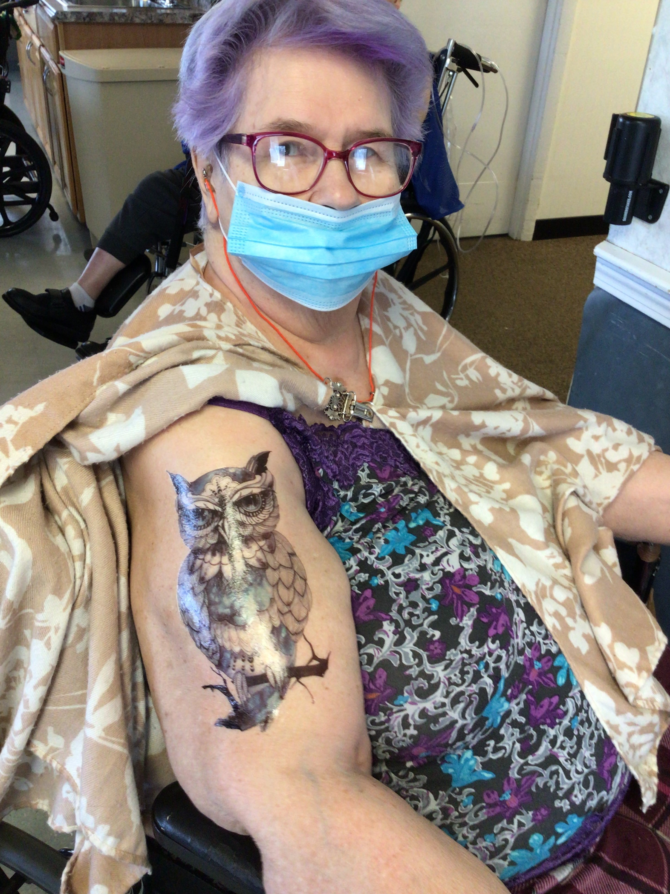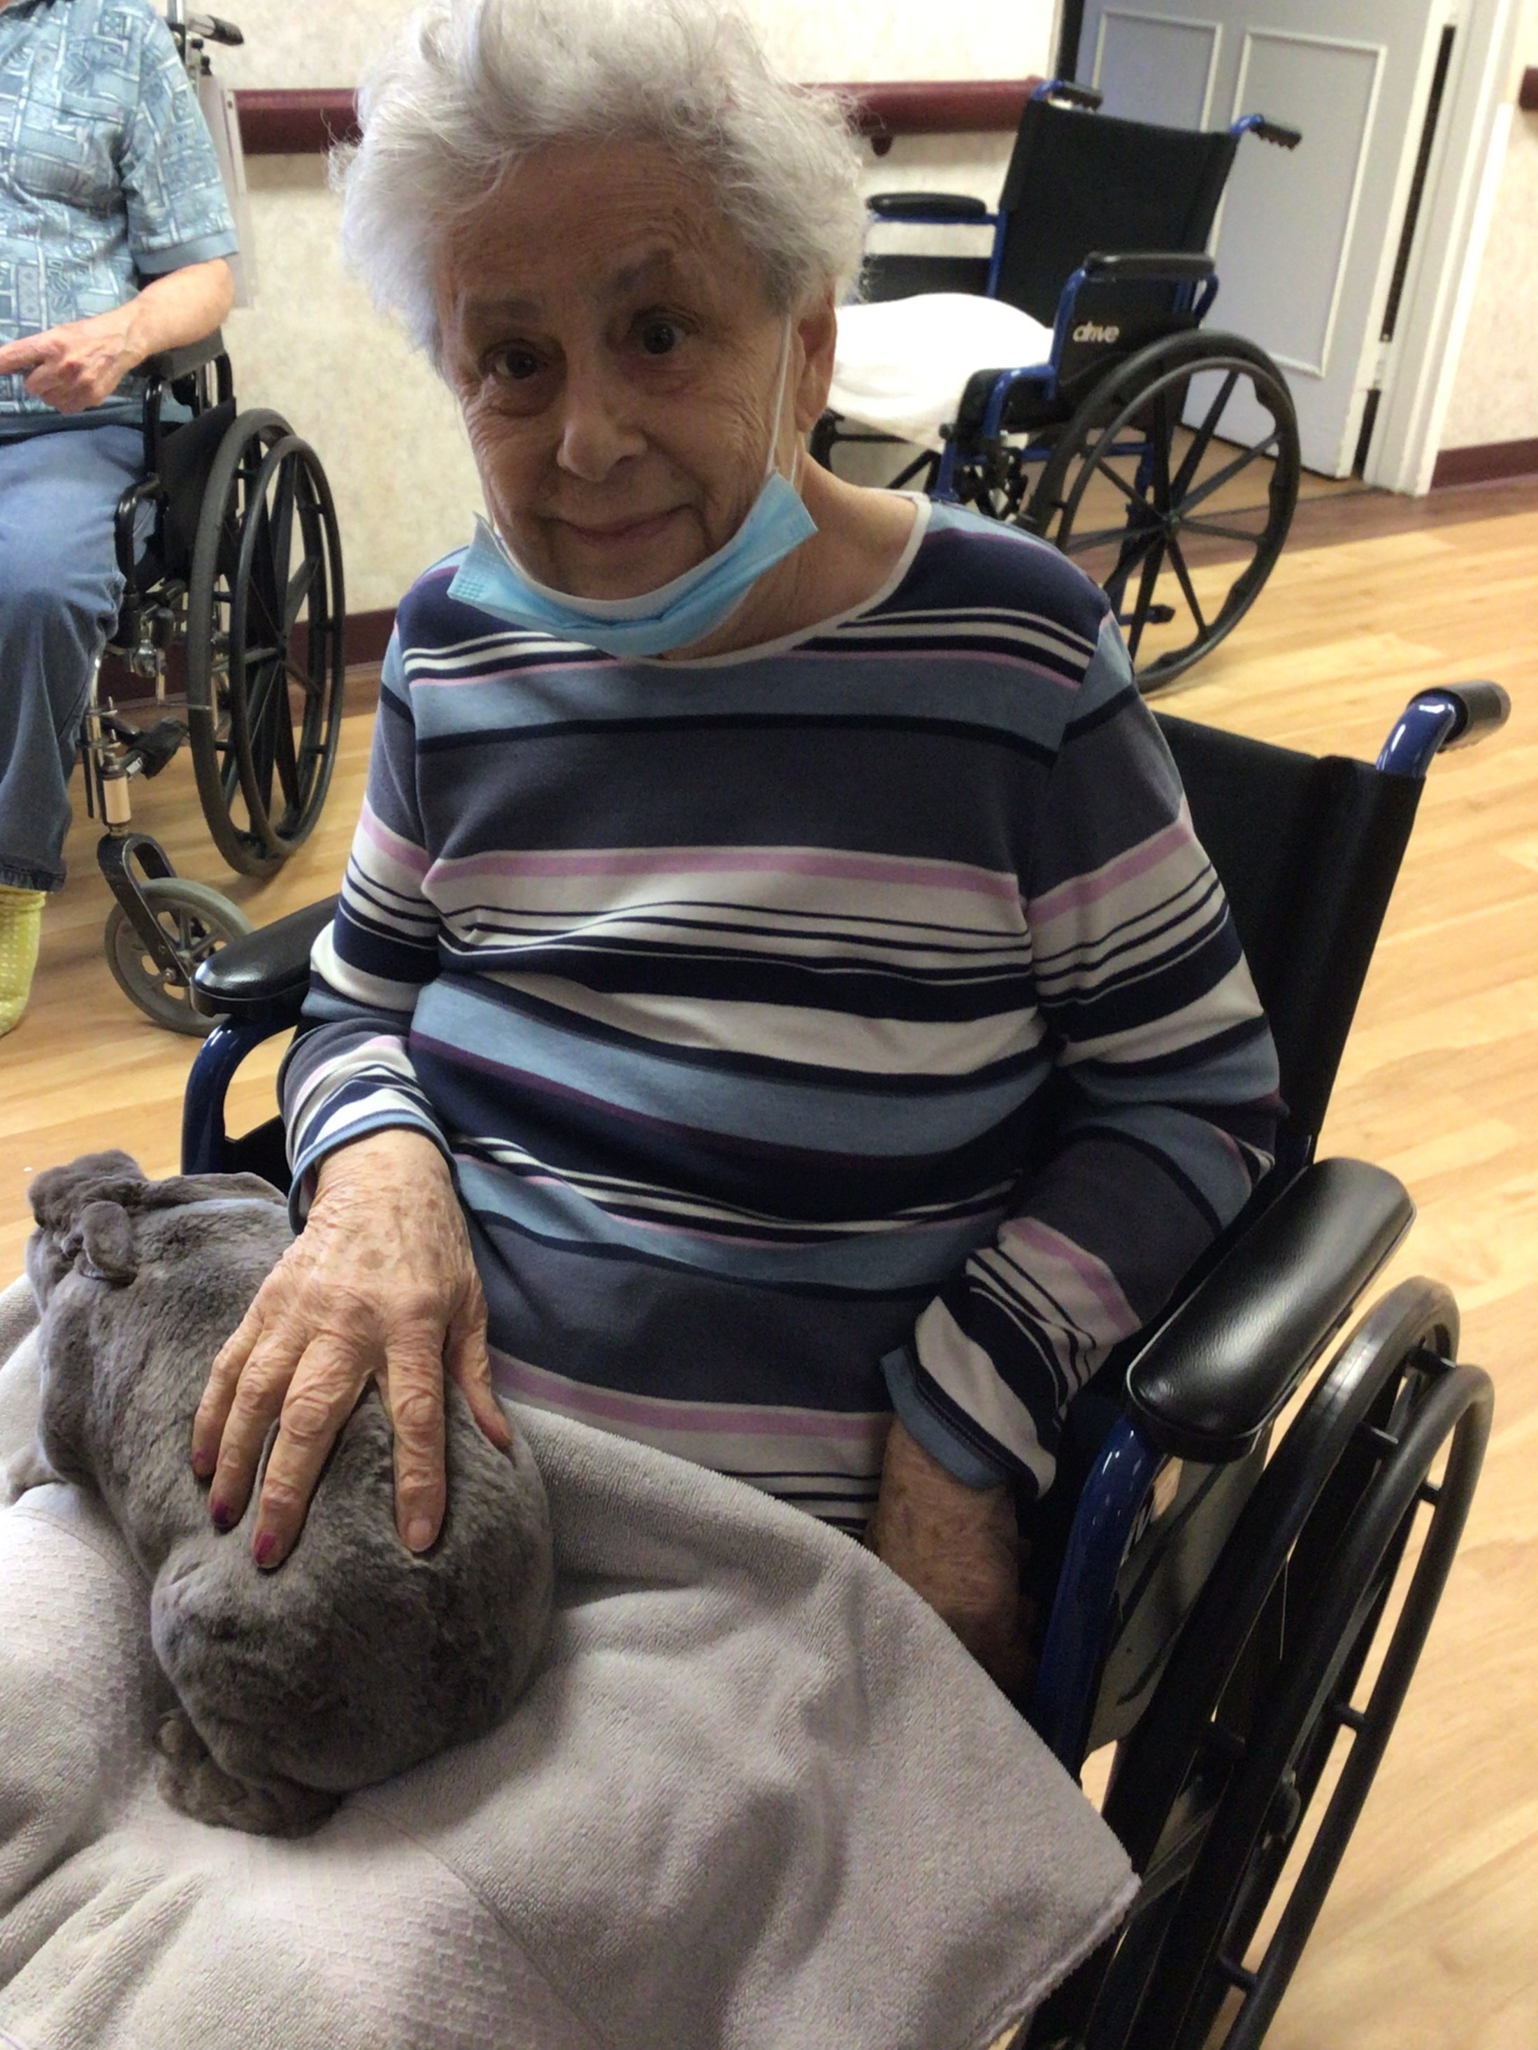  May 2022 | Princess Power  International Tiara Day falls on May 24, the same day as Queen Victoria’s birthday. How many parents have watched their young kids don a frilly pink ballgown and tiara and play princess? Some might blame the corrupting influence of Disney. Others, though, consider the tiara a potent symbol of feminine power and majesty. Some experts argue that so-called “princess play” offers children a window into feminine power. After all, princesses are born to rule.  Ironically, the word tiara was first used by the Greeks to describe the high headdresses worn by ancient Persian kings, not queens. It wasn’t until the late 18th century that tiaras, as worn by female royals, surged in popularity. Unlike  a crown, which is circular, a tiara is only semi-circular, designed to cover half the head. That does not mean it is half as valuable. The Greville Emerald Kokoshnik tiara, valued at $18 million, was made by French jeweler Boucheron in 1919 for Dame Margaret Greville, who bequeathed it  to Queen Elizabeth in 1942.  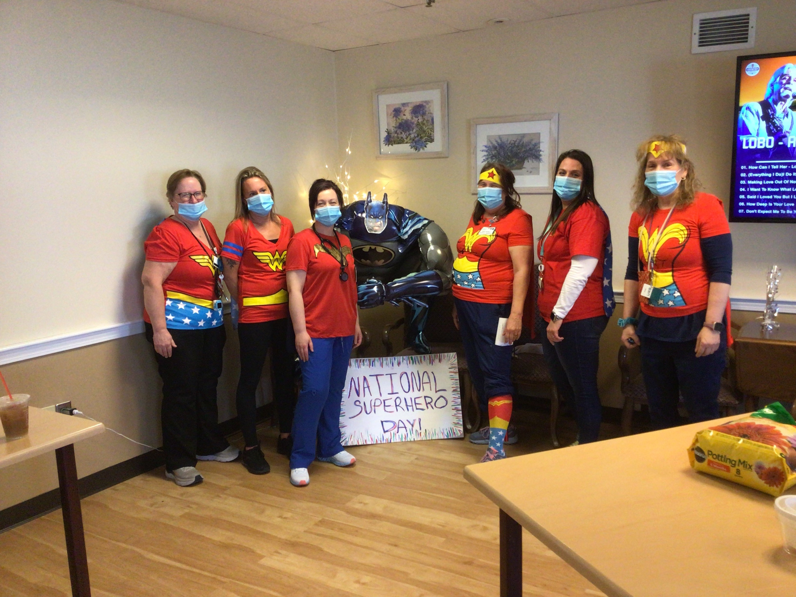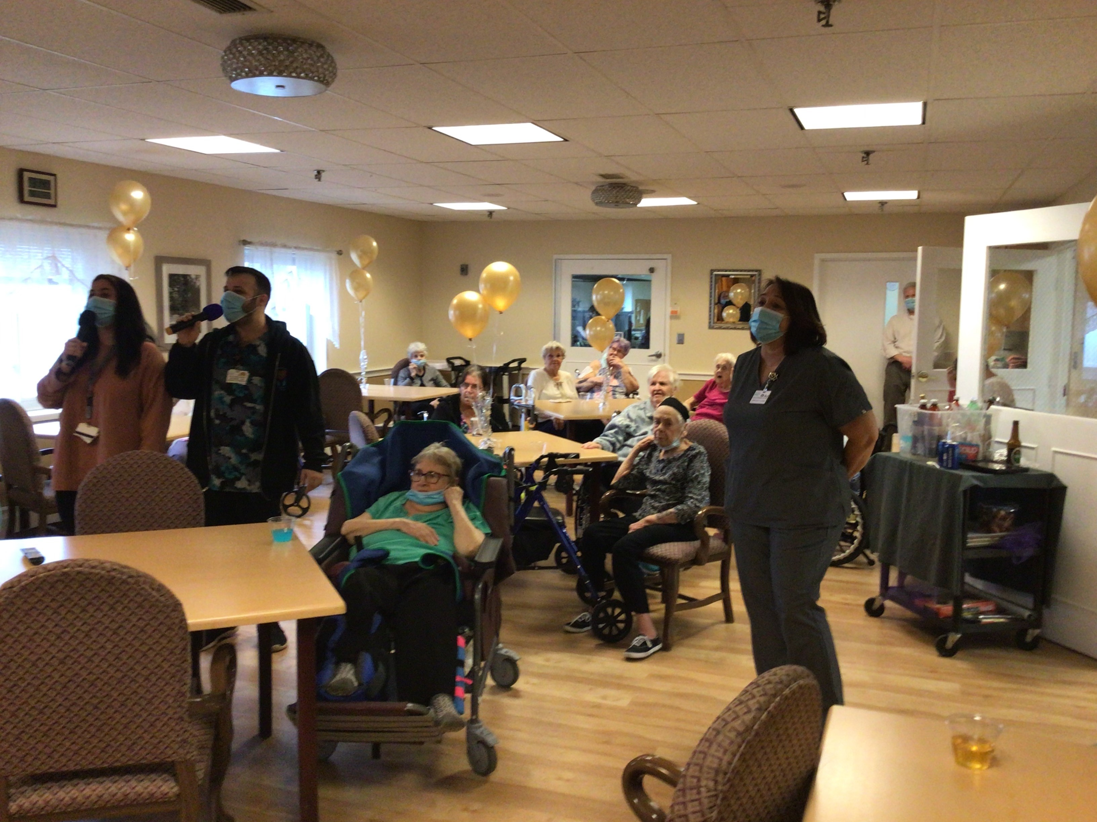
Meditate on This  Take a deep breath and relax. May is Meditation Month. Meditation might have gone mainstream thanks to popular practices like yoga and tai  chi, but meditation is a practice that dates back many millennia.  May 2022  While some archaeologists date meditation back to 5000 BC, and some anthropologists speculate that even our Neanderthal ancestors might have meditated, the earliest written records referencing meditation date to around 1500 BC in India.  The Hindu tradition of Vedantism included the practice of Dyana, a pursuit of enlightenment that emphasized “the training of the mind.” The word meditation comes from the Latin meditatum, meaning “to ponder.” The notion that meditation is closely linked to the mind has persisted across various cultures for thousands of years.  Specifically, meditation is a technique used to calm and clear the mind. The Buddha, although he did not invent meditation,  used it as a means to achieve enlightenment. Lao Tzu, the Chinese sage and author of the Tao Te Ching, wrote, “Be still. Stillness reveals  the secrets of eternity.” Meditation has long served as a valuable tool during humanity’s relentless search for the meaning of life.  Today, modern science shows us that meditation benefits the body just as much as it benefits the mind. In 1967, Dr. Herbert Benson of Harvard’s Medical School found that people who meditated used 17% less oxygen, lowered their heart rates, and increased brain waves that aided sleep. He called these effects “the relaxation response.” Studies now confirm that meditation reduces anxiety, promotes emotional health, enhances self-awareness, improves sleep, controls pain, and can even make you more kind. Meditation isn’t a miracle or magic. All it takes is deliberate practice. Dr. Benson might have put it best  when he said, “All I’ve done is put a biological explanation on techniques that people have  been utilizing for thousands of years.” | Motivated! Dependable! Ambitious!  Meet BNRC’s Staff  Meet Bill McGrath  Facility Operations Director  Bill is the Facility Director here at BNRC.  He has been with BNRC since September of 2020. He grew up in Manchester NH. Prior to his employment here he was an electrician for 27 years and he operated his own business.  When not working Bill enjoys kayaking, hiking, working out at gym, and playing or coaching soccer. He has two dogs, a bird, and a fish. His favorite candy is a three musketeers and favorite food is chicken alfredo.  Bill has been an incredible asset to BNRC. All his hard work and efforts are greatly appreciated. Keep up the GREAT work Bill.
May 2022  Resident Review  Meet Barbara Curran  Barbara is May’s Resident of the Month. She is known for her witty personality and amazing creative talent. She likes to be called Barbie.  She was born in Dorchester, MA in a house. She worked as a housekeeper her whole life.  Some of her favorite activities are bingo, coloring, cornhole, bowling, tattoos, and chasing the nurses around.  Her favorite color is purple and likes most everything. She never had any pets growing up but absolutely loves the stuffed animals she wins at bingo games.  Stop in and see her sometime on the north wing, she is guaranteed to make you laugh!  _______________________________________  “A MOTHER’S LOVE”  A Mother’s love is something that no one can explain.  It is made of deep devotion and of sacrifice and pain.  ---Helen Steiner Rice  Happy Mother’s Day To All Of Our Mom’s!! | May Birthdays  In astrology, those born May 1-–20 are Bulls of Taurus. Like bulls in a pasture, Taureans enjoy relaxing in serene environments. They also work hard and expect a reward for their efforts. Those born from May 21–31 are Twins of Gemini. Perhaps because twins are born with a companion, Geminis love to communicate with others. They are flexible and clever extroverts who can make persuasive arguments.  Dwayne Johnson (actor) – May 2, 1972  Frankie Valli (singer) – May 3, 1934  Audrey Hepburn (actress) – May 4, 1929  Don Rickles (comedian) – May 8, 1926  Stevie Wonder (musician) – May 13, 1950  Janet Jackson (singer) – May 16, 1966  Malcolm X (activist) – May 19, 1925  Mr. T (actor) – May 21, 1952  Bob Dylan (musician) – May 24, 1941  Sally Ride (astronaut) – May 26, 1951  Betty Shabazz (activist) – May 28, 1934  Brooke Shields (model) – May 31, 1965  From The Directors Desk  Hello Residents, Families and Friends,  I am sending this newsletter out with much excitement. April for BNRC was a busy month. Some new activities were offered and received with smiles and some fresh excitement. I have provided many pictures in this newsletter for your viewing. Our activities consisted of a new Zumba Class, a Spiritual Meditation Class, Booze & Tattoo’s Activity, Karaoke & Cocktails, Eddy the Pony Visit, a Food Tasting Party, and Live Bunny Visits on Easter. The residents also enjoyed our Superhero Day on April 28th.  Coming in May: A new Art Class, Memorial Day Ceremony and John Wayne Movie Marathon Month.  I would again like to ask if anyone has any interest in volunteering or would like more information regarding volunteering. We have ample opportunities for volunteers in our facility.  I wish all mom’s a wonderful and blessed Mother’s Day!!  Life Enhancement Director (603-)627-4147 ext. 107  Kimberly LaFleur

